**Lab Task 4**

**My First Application: Option Menu & Check box**

**Objective:** This lesson will show you how to create option menu and check box in your application.

1. Opening LiveCode

[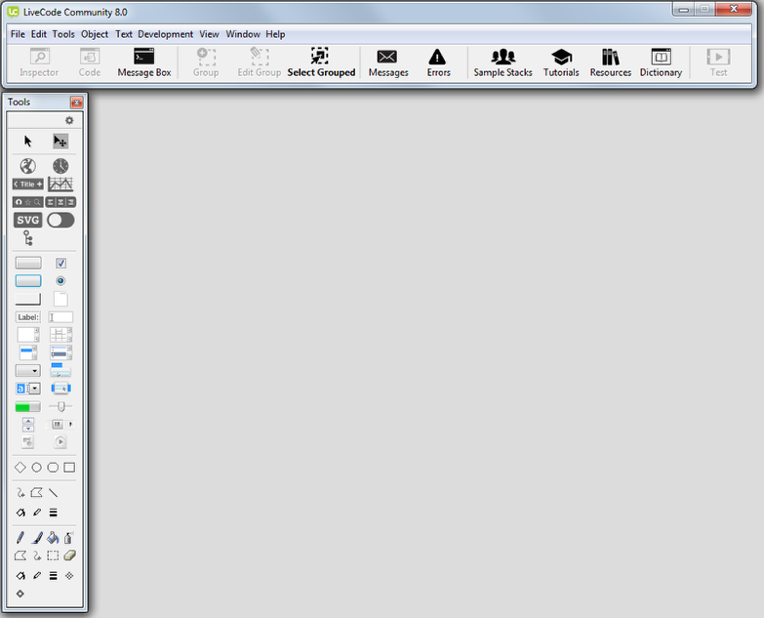](http://lessons.livecode.com/m/2571/l/121876-hello-world/show_image?image_id=9008978)

Start LiveCode, you will see the Integrated Development Environment or IDE.

2. Creating a new mainstack

[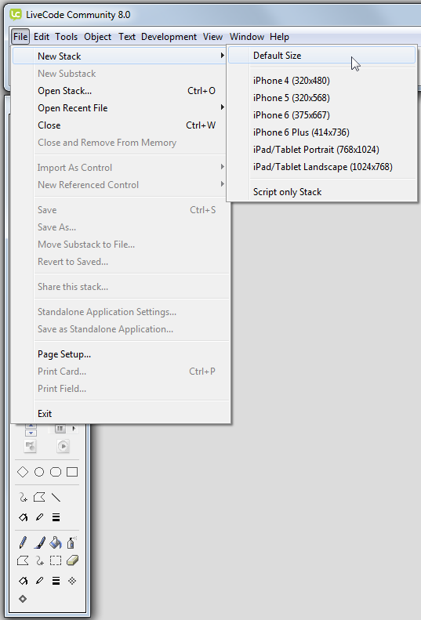](http://lessons.livecode.com/m/2571/l/121876-hello-world/show_image?image_id=9008981)

Select **New Stack - Default Size** from the File menu. Every project you create in LiveCode is a stack.

New stack

[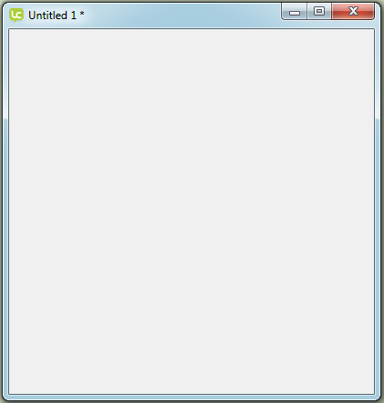](http://lessons.livecode.com/m/2571/l/121876-hello-world/show_image?image_id=8618077)

This is a new stack, it is a blank canvas ready for you to start creating your app.

3. Creating an option menu

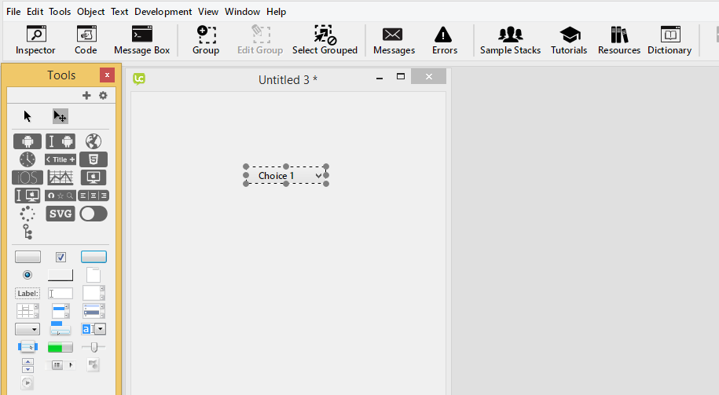

Drag an option menu from the Tools Palette onto the stack.

4. Open the Code Inspector and update menu items info

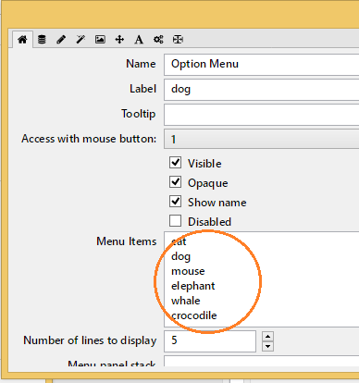

4. Opening the Code Editor and add code.

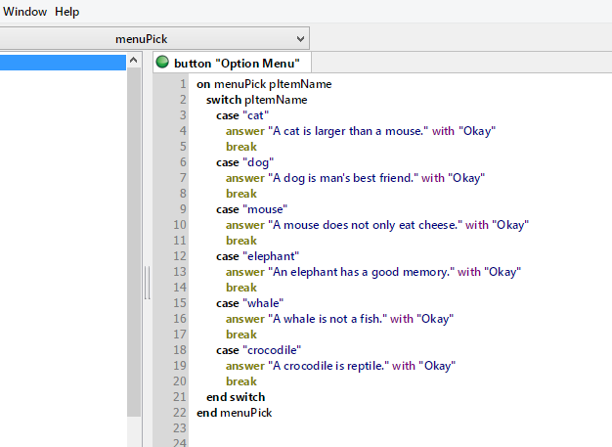

5. Test the option menu

6. Creating a check box

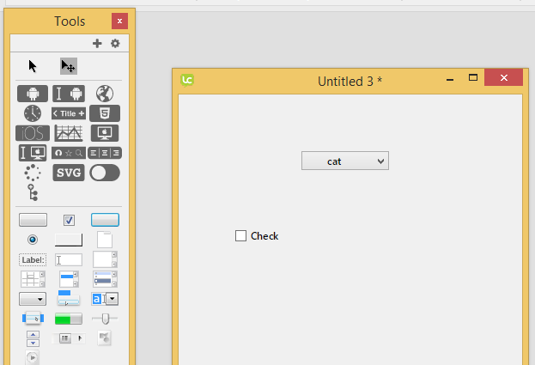

Drag a check box from the Tools Palette onto the stack.

7. Open the Code Inspector and update name

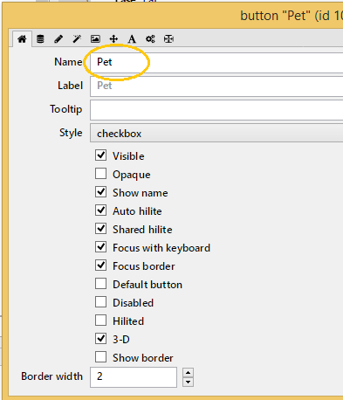

8. Creating an Enter button

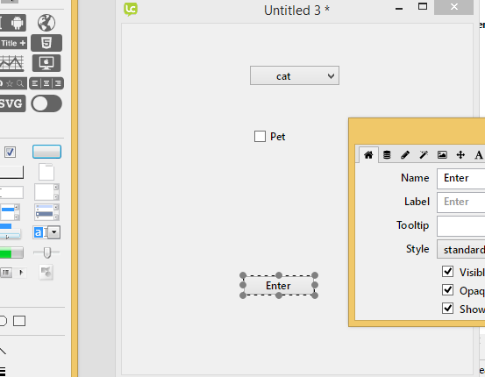

Drag a button from the Tools Palette onto the stack. Then edit the Name (Enter) in Code Inspector.

9. Add the following code.

1. Edit Option Menu Script

Declare a varAnimal variable and assign animal name to the variable. Apply the assignment statement to all case.

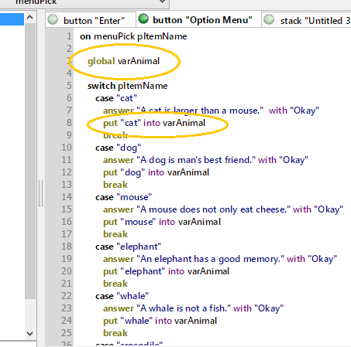

1. Add code in Button Enter Script

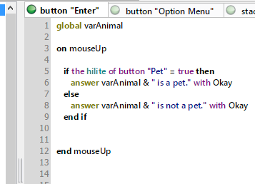

**Tutorial Question:**

1. Create a Restaurant Calculator application that will calculate total price of selected menu. Refer to below table for detail of price.

|  |  |
| --- | --- |
| **Menu** | **Price** |
| A | RM15 |
| B | RM20 |
| C | RM25 |
| D | RM30 |
| E | RM35 |
| Take Away charge is RM1.00 | |

